H.T No
Regulations:
A18

Sreenidhi Institute of Science and Technology
(An Autonomous Institution)
Code No: 7K404 Date: 27-Jan-2025 (AN)

B.Tech II-Year II- Semester External Examination, January - 2025 (Supplementary)
MECHANICS OF MATERIALS (CIVIL)

Time: 3 Hours Max.Marks:70

Note: a) No additional answer sheets will be provided.
b) All sub-parts of a question must be answered at one place only, otherwise it will not be valued.
c) Missing data can be assumed suitably.

Bloom's Cognitive Levels of Learning (BCLL)

Remember | L1 | Apply | L3 | Evaluate | L5
Understand | L2 | Analyze | L4 | Create | L6

Part - A Max.Marks:20
Answer all QUESTIONS

 |  | BCLL | CO(s) | Marks
1 | What is hoop stress and explain why hoop stress is required. | L2 | CO1 | [2M]
2 | List any two applications of theories of failures. | L2 | CO2 | [2M]
3 | What is shear force and bending moment diagram? | L2 | CO3 | [2M]
4 | What is static indeterminacy? | L2 | CO4 | [2M]
5 | What is principle of superposition in beams? | L2 | CO5 | [2M]
6 | Define the terms : column and crippling load. | L2 | CO6 | [2M]
7 | A thin cylinder of diameter d is subjected to internal pressure p. Write down the expression for hoop stress and longitudinal stress. | L2 | CO1 | [2M]
8 | Draw the shear force diagram for a cantilever beam with a point end load W and length L. | L2 | CO3 | [2M]
9 | Define the terms : column and crippling load. | L2 | CO5 | [2M]
10 | What is principle strain theory? | L2 | CO2 | [2M]
Part – B Max.Marks:50
ANSWER ANY FIVE QUESTIONS. EACH QUESTION CARRIES 10 MARKS.

 |  |  | BCLL | CO(s) | Marks
11. | a) | Explain the effect of internal pressure on the dimensions of a thin cylindrical shell. | L4 | CO1 | [5M]
 | b) | A thin cylinder of internal diameter 1.5m contains a fluid at an internal pressure of 2 N/mm² . Determine the maximum thickness of the cylinder.  i) The longitudinal stress is not exceed 40 N/mm²  ii) The circumferential stress is not exceed 45N/mm². | L3 | CO1 | [5M]
12. | a) | Explain in detail about Maximum shear stress theory. | L3 | CO2 | [5M]
 | b) | Explain in detail about Maximum principal stress theory. | L3 | CO2 | [5M]
13. |  | Draw the shear force and Bending moment diagram for the simply supported beam.  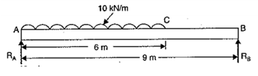 | L4 | CO3 | [10M]
14. |  | Determine the forces in all the members of the truss as shown in the fig.  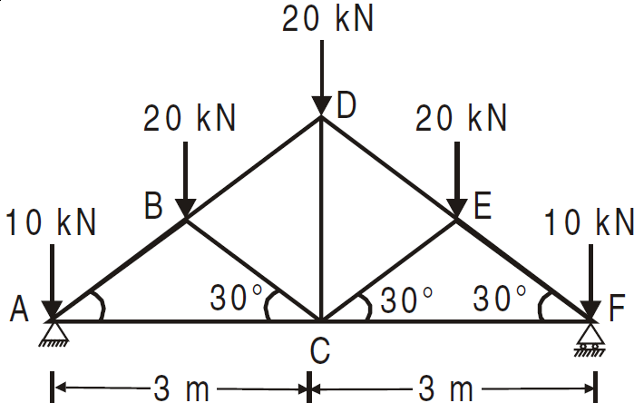 | L4 | CO4 | [10M]
 |  |  |  | CO4 | [5M]
15. | a) | Define castiglianos & Maxwell-betti reciprocal theorem. | L5 | CO5 | [5M]
 | b) | Derive the moment - curvature relationship with a neat diagram. | L4 | CO5 | [5M]
16. |  | A rolled steel joist ISMB 300 is to be used a column of 3 meters length with both ends fixed. Find the safe axial load on the column. Take factor of safety 3, fc = 320 N/mm² and a = 1/7500 . Properties of the column section. Area = 5626 mm², I XX = 8.603 x 10⁷ mm⁴ Iyy =4.539 x 10⁷ mm⁴ | L4 | CO6 | [10M]
17. | a) | State the assumptions made in the analysis of pin jointed trusses. | L2 | CO1 | [4M]
 | b) | Explain stress and strain tensor. | L1 | CO2 | [3M]
 | c) | Explain the point of conraflexure in a beam. | L3 | CO3 | [3M]
18. | a) | Explain in detail about force deformation relationships of deformable bodies | L3 | CO4 | [4M]
 | b) | What is the ratio of torsional moments of resistance of a solid circular shaft of diameter D to that of a hallow shaft with external diameter D and internal diameter ‘d’? | L4 | CO5 | [3M]
 | c) | What are the assumptions made in Euler’s Theory. | L3 | CO6 | [3M]

-- 00 -- 00 –

